**LINKED PROCESS**

**In the middle of one BPD/Process, if we want to call another BPD/Process then we go for linked process**.

**Linked process is reusable.**

**Linked process is having data mapping.**

**In terms of performance while calling one BPD to another BPD linked process is good as both the BPD’S are running under one instance only.**

**Step1: I have created one BPD.**

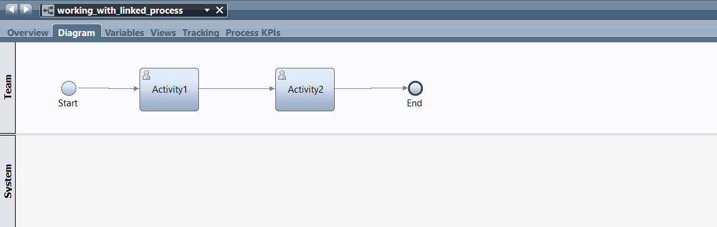

**Step2: I have created another BPD.**

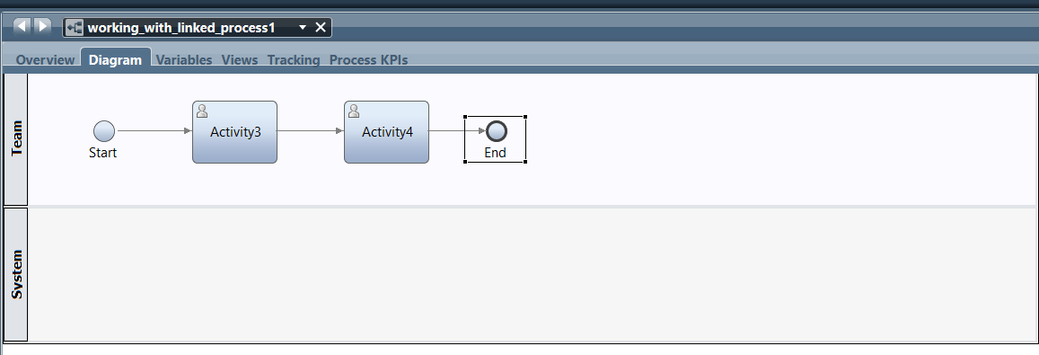

**Step3: we will create variables for both BPD’s.**

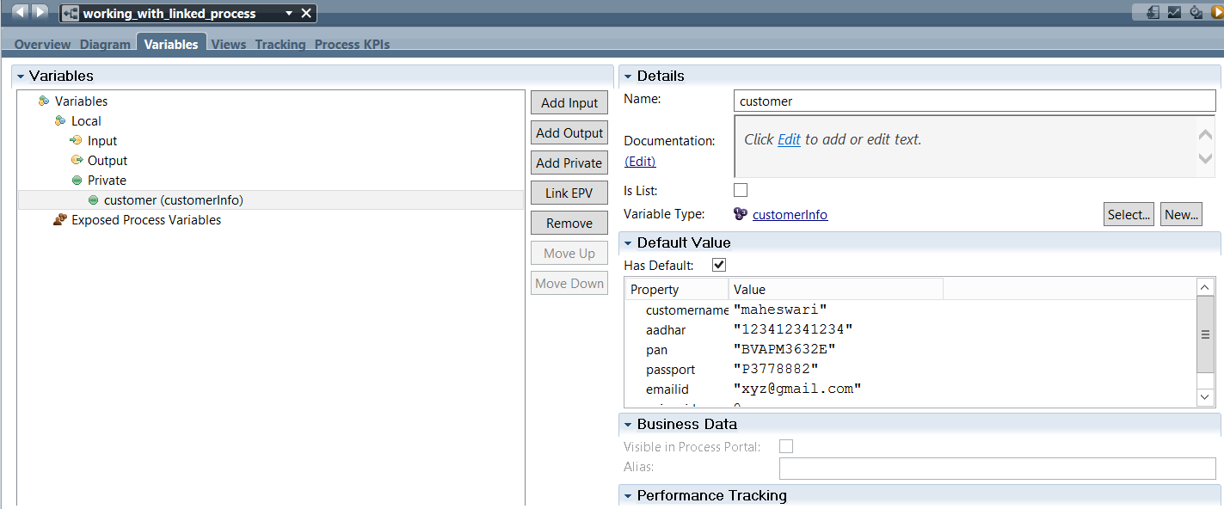

**Step4: Click on processes, it will display the BPD’s what we have created, drag the process and drop into bpd, you can see in the below image.**

**After running the process the token will be moved from activity1 to linked process after that the token will be moved to activity2.**

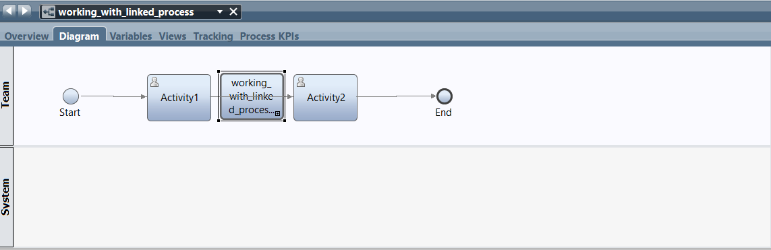

**Step5: After running the BPD, the token will be moved and task will be completed like this.**

